As part of an initiative to make rejoining work post-maternity leave easy, techie mothers are being assigned to team projects in the most optimal fashion. Given the skills of n new-mom developers having IDs denoted by 0, 1, 2...n – 1 respectively where the skill of the ith developer is denoted by developerSkill[i], a team of k developers is to be formed for working on a project. We define the effort on a project of difficulty x as follows:

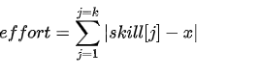

where |a| represents the absolute value of a and skill[j] represents the developerSkill of the jth developer from the chosen group of k developers.

Given the skill values, and the team size k, find the minimum team effort of a team that can be chosen, if they choose the project difficulty optimally. Note that the chosen difficulty x can only be an integer value.

**Example**

Consider the number of developers to be n = 7, their skills to be developerSkill = [3, 9, 5, 1, 8, 6, 4], and the team size to be k = 3. One of the possible teams can be formed with the second, third and fifth developers. Their skillset would be represented by [9, 5, 8]. Suppose we choose a project of difficulty x = 6. Then their effort is given by |9 – 6| + |5 – 6| + |8 – 6| = 3 + 1 + 2 = 6.

However, upon choosing the first, third and last developer, with skills [3, 5, 4] and a project of difficulty x = 4, the team effort needed = |3 – 4| + |5 – 4| + |4 – 4| = 1 + 1 + 0 = 2, which is the minimum possible. Hence, the answer is 2.

**Function Description**

Complete the function findMinimumEffort in the editor below.

findMinimumEffort has the following parameters:

int developerSkill[n]: the skill level of developers

int k: the required team size

**Returns**

long_int: the minimum team effort by choosing a team of size k

**Constraints**

* 1 ≤ k ≤ n ≤ 105
* 1 ≤ developerSkill[i] ≤ 109

**Input Format For Custom Testing**

The first line contains an integer, n, denoting the number of elements in developerSkill.  
Each line i of the n subsequent lines (where 0 ≤ i < n) contains an integer describing developerSkilli.

The next line contains an integer, k, denoting the required team size.

**Sample Case 0**

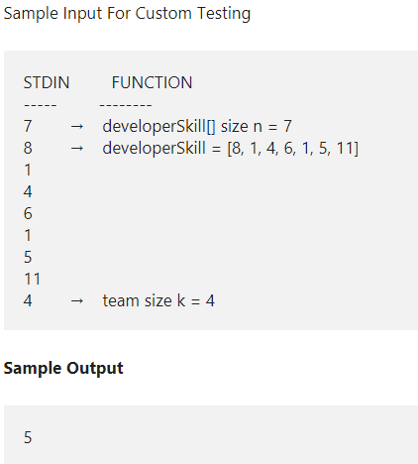

**Explanation**

Given, n = 7, developerSkill = [8, 1, 4, 6, 1, 5, 11], k = 4. We can choose the developers with skill sets [8, 4, 5, 6] and assign them a project of difficulty 6. The corresponding effort would be |8 – 6| + |4 – 6| + |5 – 6| | + |6 – 6| = 5. Note that the same effort is obtained with a project of difficulty 5 as well. No other set of developers can produce a more optimal effort with a project of any difficulty.

**Sample Case 1**

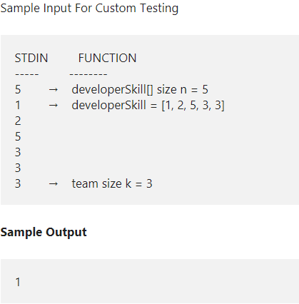

**Explanation**

We can choose the developers with skill sets [2, 3, 3] and assign them a project of difficulty 3. The effort thus obtained would be equal to 1 which is the minimum possible effort achievable.